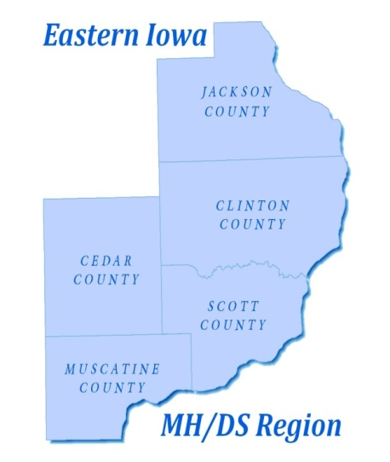

EASTERN IOWA MENTAL HEALTH AND DISABILITY SERVICES REGION

Eastern Iowa MHDS Advisory Committee Meeting
Scott County Administration Building
Room 638
Monday, July 16, 2018
1:00 p.m. to 2:30 p.m.

- Introductions
- Review Agenda
- Recommendations for Member (Active Relative or Individual Receiving Services) to Serve as Ex Officio Member on Governing Board
- Presentation from Todd Noack- Peer Support Services
- Update on Region’s Financials
- Update on Crisis Services
- Other Items
- Public Comment
- Future Meetings/Set Dates
- Adjournment

