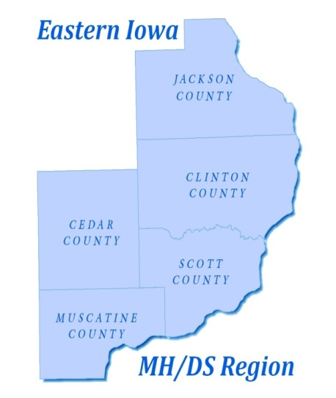

EASTERN IOWA MENTAL HEALTH AND DISABILITY SERVICES REGION
Governing Board of Directors Work Session
Scott County Administrative Center
First Floor Boardroom
February 15, 2019
1:00-3:00 p.m.

- Roll Call
- Discussion on FY20 Budget
- Other Items
- Adjournment

