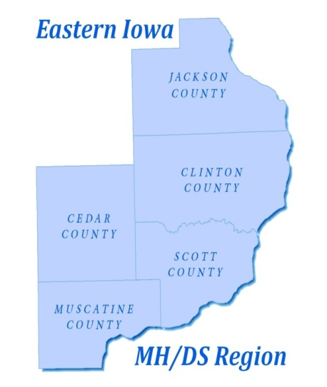
EASTERN IOWA MENTAL HEALTH AND DISABILITY SERVICES REGION
Governing Board of Directors Board Meeting
Davenport Public Library
3000 North Fairmount St.
November 19, 2018
3:00-5:00 p.m.
- Roll Call
- Review Agenda
- Discussion and Action for Approval of Minutes from 10/22/18 Governing Board Meeting
- Discussion and Possible Action on the Regional Financial Report- David Farmer
- Presentation on Peer Support Services- Todd Noack
- Updates on Grant Funding Outcomes (Rhonda’s House)- CEO
- Crisis Services Update from Robert Young Center
- Update on Workgroups- Commitment, Tertiary, Children’s System- CEO
- CEO Report
- Other Items- Strategic Planning Sessions: December 6 and 13, 2018
- Public Comment - Visitors & Citizens (Public comments will be limited to 3 minutes per individual
- Adjournment

REMINDERS:
The December Governing Board meeting will be held on December 17, 2018, at 3:00 pm in room 605 at the Scott County Administrative Center.

Also on December 17, 2018, the Region will be hosting a Legislative “Meet and Greet” in room 605 at 2 pm (right before the monthly Governing Board meeting).

