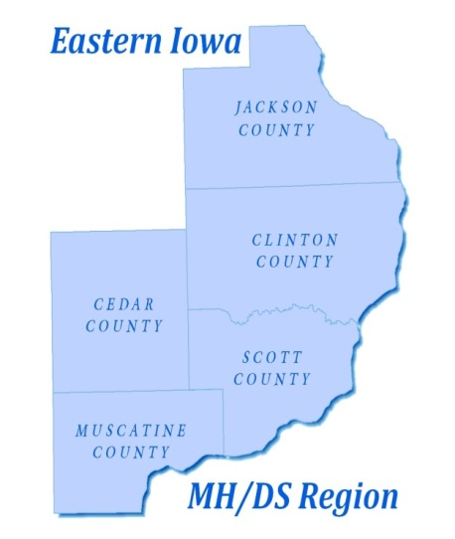

EASTERN IOWA MENTAL HEALTH AND DISABILITY SERVICES REGION
Governing Board of Directors Board Meeting
AMENDED AGENDA
Scott County Administrative Center
Room 605
October 21, 2019
3:00-5:00 p.m.
- Roll Call
- Review Agenda
- Discussion and Possible Action for Approval of Minutes from the 9/16/19 Governing Board Work Session Meeting
- Discussion and Possible Action for Approval of Minutes from the 9/16/19 Governing Board Work Session Closed Meeting
- Discussion and Possible Action for Approval of Minutes from the 9/16/19 Governing Board Meeting
- Discussion and Possible Action for Approval of Minutes from the 9/23/19 Emergency Governing Board Meeting
- Discussion and Possible Action to Approve the Regional Financial Reports- David Farmer
- Discussion on the Financial Position of the Region- David Farmer/Lori Elam
- Discussion and Possible Action to Approve the Fiscal Year 2019-2023 Audit Contract
- Crisis Services Update from Robert Young Center
- Discussion and Possible Action to Approve Late Invoices
- CEO Report- Lori Elam
- Other Items
- Public Comment - Visitors & Citizens (Public comments will be limited to 3 minutes per individual
- Adjournment

Next Meeting- November 18, 2019 at 3 pm in Room 605, Scott County Administrative Center

